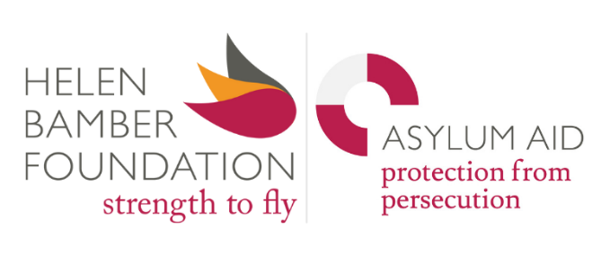
VOLUNTEER ILLUSTRATOR

Ideal time commitment: Create 20 illustrations and conduct 1 or 2 workshops with our Ambassadors for Change group (time commitment is open to discussion and dependent on capacity of illustrator)

Reports to: Communications Manager

Starting date: As soon as possible

Location: Helen Bamber Foundation, 26 - 30 Westland Place, London N1 7JH. This role can be fully remote.

Deadline: 30th November 2025, interviews will be conducted on a rolling basis

ABOUT THE HELEN BAMBER FOUNDATION AND ASYLUM AID
The Helen Bamber Foundation, founded in 2005 by the pioneering human rights advocate Helen Bamber, was created to reflect the evolving global patterns of violence and persecution. Helen Bamber, who entered Bergen-Belsen Concentration Camp in 1945 as part of one of the first rehabilitation teams, recognised that all survivors of extreme violence—regardless of the perpetrator—require safety, legal protection, and medical and emotional support. Today it is a specialist clinical and human rights charity that works with people seeking asylum and refugees who are survivors of trafficking, torture and other forms of extreme human cruelty. The Helen Bamber Foundation's unique Model of Integrated Care (MoIC) provides holistic support encompassing therapy, legal advocacy, medical treatment, and practical assistance, helping survivors rebuild their lives with safety, freedom, and dignity.

In 2020, the Helen Bamber Foundation joined forces with Asylum Aid (established in 1990) to form the Helen Bamber Foundation Group. Asylum Aid specialises in providing legal representation to vulnerable individuals seeking asylum, focusing on the most complex cases including survivors of trafficking, children, and stateless people. Asylum Aid is a leading actor in strategic litigation and advocates for policy and systemic changes to remove barriers to protection and justice. Asylum Aid maximises its impact by providing training and working in partnership with other organisations.

Together, we are innovative, ambitious and compassionate. The bravery and resilience of our clients is an inspiration to all the team at Helen Bamber Foundation Group. We believe that all survivors should have safety, freedom and power to rebuild their lives.

ABOUT THE ROLE
We are looking for a creative and passionate volunteer illustrator to bring to life the stories of survivors, our campaigns and publications through visual artwork. You will shape the visual storytelling of complex messages across our website and social media channels, including Instagram, Bluesky, and LinkedIn. Your illustrations will play a key role in our advocacy, marketing and fundraising work.
This role is ideal for an illustrator who wants to use their artistic skills to help shape compassionate narratives about people seeking asylum and refugees, and to support human rights and trauma-informed advocacy.

MAIN TASKS AND ACTIVITIES
- Create 20 original illustrations to be used for various purposes such as the charity’s social media posts, reports, campaigns and marketing. In interview, Communications Manager will share example of preferred style of images and will discuss with illustrator what their timescales/time commitment could be for completion. The illustrator can work remotely and the agreed time commitment for them can be discussed and agreed with the Communications Manager.
- The creative artworks must align with Helen Bamber Foundation and Asylum Aid’s tone, branding, and trauma-informed approach.
- Help translate complex policies, personal stories and abstract concepts (such as trauma, recovery or community) into thoughtful and engaging imagery in the illustrations.
- Contribute creative ideas on how the artworks can be used across our online platforms.
- Conduct one or two workshops with our Ambassadors for Change, a group of survivors with lived experience of asylum system, to help them develop visuals that support their campaigns.
- Ensure all artwork respects the dignity and privacy of survivors and adheres to ethical storytelling and safeguarding principles.
SKILLS AND EXPERIENCE NEEDED
- Strong illustration skills and with an excellent understanding of visual storytelling.
- Experience of using digital illustration tools (e.g., Procreate, Adobe Illustrator, Photoshop, or similar) are essential.
- Ability to work collaboratively, interpret briefs and respond constructively to feedback.
- Understanding of inclusive and ethical design practices and demonstrate sensitivity when representing trauma and human rights issues.
- Understanding of, and commitment to, the objectives of the Helen Bamber Foundation and Asylum Aid.
- Demonstrable empathy for our clients, including people seeking asylum, refugees and survivors of torture and trafficking, and sensitivity when working on topics related to human rights, trauma, or lived experience.
- Organised, dependable, and proactive in meeting deadlines.

WHAT YOU WILL GET OUT OF THE ROLE
- The opportunity to use your creativity to support survivors and advocate for human rights.
- Experience of working within human rights charities with a focus on advocacy-driven communications.
- Portfolio development for cause-driven work.
- A chance to contribute directly to meaningful change for people rebuilding their lives and raising awareness.
- A strong understanding of communications and advocacy work of leading human rights charities.
- An appreciation of the processes and systems that people seeking asylum and refugees deal with in the UK.
HOW TO APPLY
- To apply please send us a CV along with a short cover letter (max 300 words) about why you would like to volunteer as an illustrator with us.
- A link or PDF portfolio with samples of your work.

We will be conducting interviews for this role on a rolling basis so please apply early.
If you have any questions or wish to have a chat about the role, please contact the Communications Manager, Kennith Rosario at kennith.rosario@helenbamber.org

